

**YEAR: 9**

**2020**

**SUBJECT: Science**

**TEST: Light & Sound**

**TIME: 50 minutes**

**QUESTIONS: 13 Multiple Choice (13 marks)**

**8 Short Answer (29 marks)**

**1 Extended Answer (5 marks)**

**TOTAL MARKS: 47 marks**

**DO NOT WRITE ON OR MARK THIS PAPER**

**SECTION ONE—MULTIPLE CHOICE** (13 marks)

This section has **13** questions. Answer **all** questions on the separate Multiple-choice Answer Sheet provided.

1. The number of times per second that an object vibrates is called its

a) wavelength.

b) oscillation.

c) frequency.

d) amplitude.

2. The pitch of a musical note is the

a) amplitude

b) quality

c) size of the vibration

d) frequency

3. In an experiment at sea level, an explosive charge was detonated at the waters edge, represented by point X on the diagram.

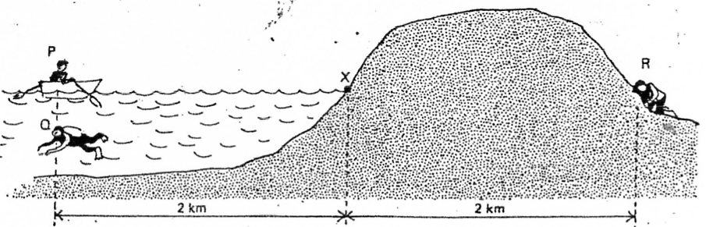

Three observers were located at equal distances from X. P in a boat, Q underwater and R with his ear to the ground.

Which one of the following statements is correct?

a) R hears the explosion first, then Q, then P.

b) P and Q hear the explosion first, at the same time.

c) P hears the explosion first, then Q, then R.

d) P and R hear the explosion first together, then Q.

4. Sound is a longitudinal wave. This means, that in respect to the direction of the wave, its particles:

a) vibrate in parallel

b) move along with the wave

c) vibrate perpendicular

d) do not move at all

5. The speed of light travelling in a vacuum is equal to:

1. 300 000 metres per second
2. 300 000 000 metres per second
3. 300 000 000 kilometres per second
4. 330 metres per second

6. Two types of wave may be generated by using a slinky. The particles in the slinky can be moved in the same direction as the wave. What type of wave is made when this happens?

a) Transverse only

b) Longitudinal only

c) Transverse and longitudinal

d) Neither transverse nor longitudinal

7. The separation of white light into its component colours is known as:

1. diffraction
2. refraction
3. dispersion
4. total internal reflection

8. An echo is an example of a sound wave

1. refracting
2. reflecting
3. diffracting
4. total internal reflection

9. A diamond has a beautiful sparkle because the light gets trapped inside it for a while before it emerges. What phenomena explain this?

1. Refracting
2. Reflecting
3. Diffracting
4. Total internal reflection

10. The volume of a musical note is the

a) amplitude

b) quality

c) size of the vibration

d) frequency

11. When putting a pen into a glass of water, the pen appears to bend. This bending of light is known as

1. refracting
2. reflecting
3. diffracting
4. total internal reflection

12. Which colours are reflected by blue paint?

1. blue only
2. red, orange and yellow
3. blue, indigo and violet
4. red only

13. In a longitudinal wave, what is it called when the particles are spread far apart?

1. Compression
2. Rarefaction
3. Amplitude
4. Wavelength



**SEMESTER TWO 2020**

**Light & Sound Test:**

**ANSWER BOOKLET**

**NAME:**

**FORM:** **DATE:**

**ASSESSMENT KEY**

|  |  |
| --- | --- |
| **I CAN STATEMENTS** | **QUESTIONS** |
| **MUST**  Explains that energy can be transferred using wave and particle models. | 2, 4, 5, 6, 7, 8, 9, 10, 11, 13, 14, 15 c, d, 17, 18, 20, 21 a,b 22 |
| **SHOULD**  Explains that energy can be transferred using wave and particle models and provides appropriate example. | 1,12,15 a, b,  16,17,18,19,21 c |
| **COULD**  Explains how energy can be transferred through different mediums using wave and particle models, relating each method to appropriate examples. | 3, 18,19, 22 |

Multiple Choice Short Answer Extended Answer Total

**/5**

**/47**

**/29**

**/13**

**SECTION ONE:** Multiple choice answers

Cross (X) through the correct answer.

|  |  |  |  |  |
| --- | --- | --- | --- | --- |
| **1** | a | b | c | d |
| **2** | a | b | c | d |
| **3** | a | b | c | d |
| **4** | a | b | c | d |
| **5** | a | b | c | d |
| **6** | a | b | c | d |
| **7** | a | b | c | d |
| **8** | a | b | c | d |
| **9** | a | b | c | d |
| **10** | a | b | c | d |
| **11** | a | b | c | d |
| **12** | a | b | c | d |
| **13** | a | b | c | d |

**SECTION TWO: SHORT ANSWER (29 marks)**

Answer the questions in the spaces provided.

14. a) “In Space, no one can hear you scream” is a quote from the movie “Alien”. **Explain** why this quote is true. (2 marks)  
  
_________________________________________________________________________________  
  
_________________________________________________________________________________  
  
_________________________________________________________________________________  
  
_________________________________________________________________________________

b) Light is able to travel through space. Explain why. (2 marks)  
_________________________________________________________________________________  
  
_________________________________________________________________________________  
  
_________________________________________________________________________________  
  
_________________________________________________________________________________

15. Label the diagram below using the terms: amplitude, wavelength, crest and trough (2 marks)

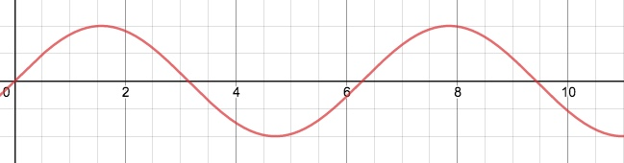

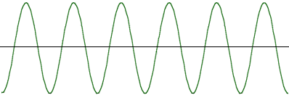16. The audio frequency oscillator was producing the following sound wave on the cathode ray oscilloscope.

Draw below what the wave will look like if the frequency of the sound were to increase (2 marks)

______________________________________________________________________________  
  
______________________________________________________________________________  
  
______________________________________________________________________________  
  
______________________________________________________________________________

______________________________________________________________________________

17. Two fire trucks with sirens on speed towards and away from an observer as shown below.

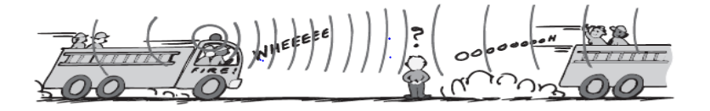

**1 2**

1. Which truck produces a higher than normal siren frequency? Explain why do you think so?

(2marks)   
_____________________________________________________________________________  
  
______________________________________________________________________________  
  
______________________________________________________________________________  
  
______________________________________________________________________________  
  
______________________________________________________________________________

1. With the help of an arrow, show in the diagram above where the wavelength is higher than normal siren frequency? Explain why do you think so? (2marks)

______________________________________________________________________________  
  
______________________________________________________________________________  
  
______________________________________________________________________________  
  
______________________________________________________________________________  
  
______________________________________________________________________________  
  
  
18. A person who is blind wants to buy a house that has large rooms. They are able to gauge the size of a room by clicking. Explain how this is possible by using your knowledge of how sound travels. (3 marks)

______________________________________________________________________________  
  
______________________________________________________________________________  
  
______________________________________________________________________________  
  
______________________________________________________________________________

19. **Draw** a diagram of a light ray hitting a mirror and obeying the Law of Reflection. Be sure to label the normal, the angle of incidence and angle of reflection. (4 marks)

20. Define the following terms and give an example of an object that is (6 marks)

1. Transparent  
     
   ___________________________________________________________________________  
     
   ___________________________________________________________________________
2. Translucent  
     
   ___________________________________________________________________________  
     
   ___________________________________________________________________________
3. Opaque

____________________________________________________________________________  
  
____________________________________________________________________________

21. Isaac Newton identified seven colours of the rainbow.

1. List the three primary colours for light. (1.5marks)
2. ______________________________
3. _____________________________
4. _____________________________
5. List the three secondary colours of light. (1.5marks)
6. ______________________________
7. _____________________________
8. _____________________________
9. Explain why they are called the primary colours of light. (1 mark)

___________________________________________________________________________  
  
___________________________________________________________________________

**SECTION THREE: EXTENDED ANSWER (5 marks)**

22. Identify **two** factors that affect the speed of sound and **explain** how they change the speed using your knowledge of energy and waves.

______________________________________________________________________________  
  
______________________________________________________________________________  
  
______________________________________________________________________________  
  
______________________________________________________________________________  
  
______________________________________________________________________________  
  
______________________________________________________________________________  
  
______________________________________________________________________________  
  
______________________________________________________________________________  
  
______________________________________________________________________________  
  
______________________________________________________________________________

______________________________________________________________________________  
  
______________________________________________________________________________  
  
______________________________________________________________________________  
  
______________________________________________________________________________  
  
______________________________________________________________________________

**END OF TEST**